**PARKING NOTES:** Zoo lot is now a pay lot (by the City). However, you do not need a neighborhood parking permit to park in the Grant Park neighborhood. Just watch for driveways, hydrants, etc. and you can park where you wish and walk over to the Zoo lot.

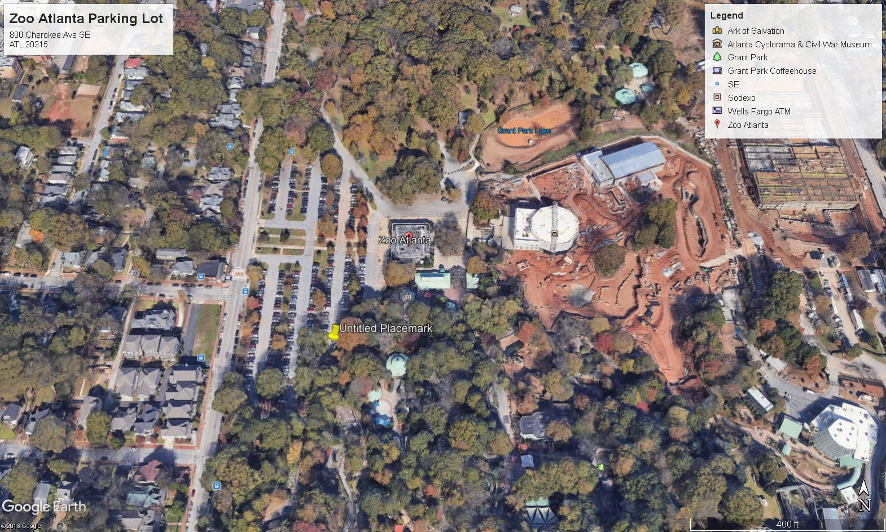

**C**

**h e r o k e e**

**A**

**v e**

Zoo is located at 800 Cherokee Ave SE, Atlanta, 30315. Cherokee Ave SE runs North-to-South. Once inside Zoo parking lot, head to the right (South), to the extreme end of the lot. We will use the big iron gate labelled “Conservation Education” (red star in the image above). Call Joe Mendelson (404.274.6318) or Andrew Schulz (405.780.0542) if you get lost or are late (see below) and we have already entered Zoo.

We’ll close that gate around 9:30 am (conference begins at 9am). If you arrive after 9:30 go to the main public entrance of the Zoo and tell them you are here for the conference with Joe Mendelson. We will have volunteer students stationed at the entrance to usher you into the Zoo and lead you to the conference venue; the students will be there until 10am. *If you are later than 10am, call Joe or Andrew at the numbers above.* You will not be able to enter Zoo (without paying) without your name badge, which will only be available at the conference venue inside the Zoo.